**Student Name : Santosh Acharya**

**Student Id : C0930325**

**Program Code : CSD 2206**

**Assignment 4**

Task 1: Create a table named Students_YYY with the following columns:

**StudentID (an integer and the primary key)**

**FirstName (a string for the student's first name)**

**LastName (a string for the student's last name)**

**Age (an integer representing the student's age)**

**Major (a string for the student's major)**

Task 2:

Inserting Records Insert at least five records into the Students table using the INSERT statement. Include a variety of data to demonstrate the different data types.

Task 3:

Updating Data Update the Major of a student with a specified StudentID.

Update the Age and Major for a student with a specified StudentID.

Task 4:

Deleting Records Delete a single record by specifying a StudentID. Delete all students with a specified Major.

Task 5: Dropping a Table Drop the Students table to remove it from the database.

**Solution :**

1. **Creating the Table**

Student_C0930325 table is created using the column level constraints and table level constraints.

1. **StudentID** has **Primary Key constraints** which is column level constraints.
2. **FirstName** is string type which use Varchar data type using **NOT NULL** constraints which is Table Level Constraints.
3. **LastName** is also string type which use Varchar data type without any constraints.
4. **Age** is an integer data type which use **CHECK constraints** to validate the age.
5. **Major** is string type which use varchar datatype.

|  |  |  |
| --- | --- | --- |
| Attributes | Datatype | Constraints |
| StudentID | Integer | Primary Key |
| FirstName | Varchar(50) | NOT NULL |
| LastName | Varchar(50) |  |
| Age | Integer | CHECK Age > 15 |
| Major | Varchar(50) |  |

* 1. **SQL query of table created with the Constraints**

The image shows the SQL Query of the table created. Where table name is Student_C0930325 with all the attribute and column level constraints and table level constraints.

Output to show the query has run or display the error

SQL Query to create table and constraint.

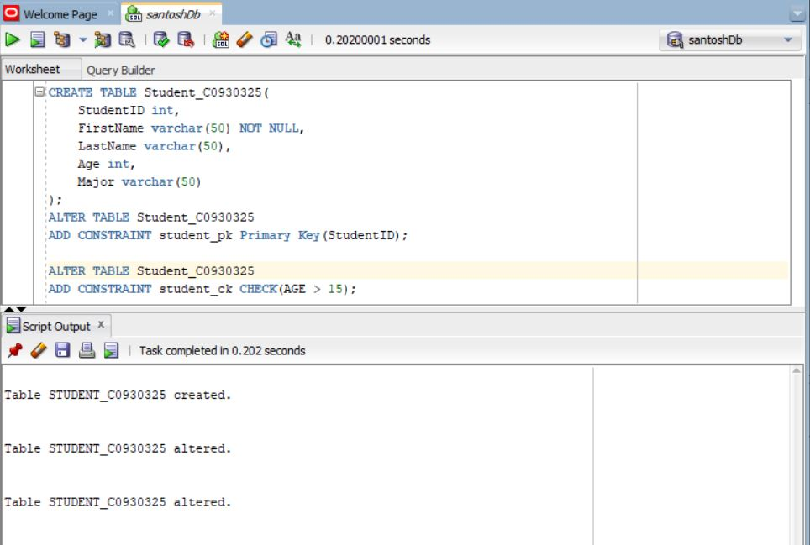

The below image shows the break-down of the SQL query used to make the database in Oracle.

1. **SQL Query of table created**

The Sql Query of to create the table is

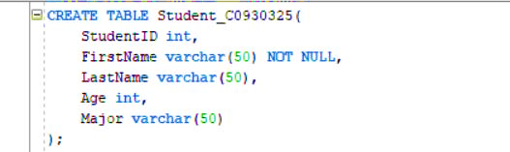

1. **Table Level Constraint**

* This image shows the table level constraints added later in the table using Alter.
* Table level constraints are easy to implement and drop while creating the table in compare to column level table.

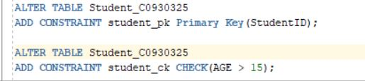

1. **Inserting data into table**

* Insert is used to enter the value into table. Inserting data into can be perform in different methods.

1. Inserting data with the syntax where column name is specify along with the values inserted into the table.

|  |
| --- |
| Insert into Student_C0930325(StudentID, FirstName, LastName, Age, Major)  Values(4,’Roshan’,’Acharya’,25,’BDM’);  Insert into Student_C0930325(StudentID, FirstName, LastName, Age, Major)  Values(5,’Soniya’,’Bhattarai’,19,’FSDM’); |

1. Inserting data with the syntax where the column name is not specify but only the values inserted into the table.

|  |
| --- |
| Insert into Student_C0930325  Values(1,’Santosh’,’Acharya’,20,’FSDM’);  Insert into Student_C0930325  Values(2,’Anish’,’Thapa’,22,’CPCM’);  Insert into Student_C0930325  Values(3,’Ram’,’KC’,22,’FSDM’); |

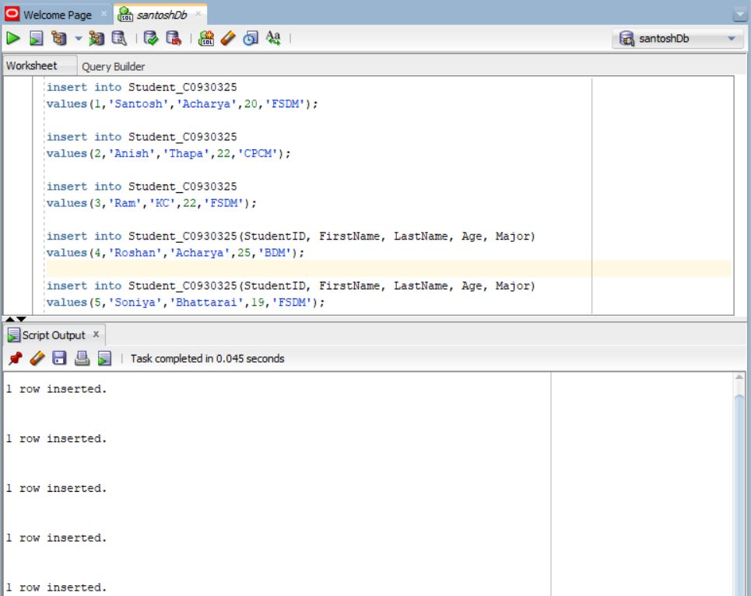

Output to show each data has been inserted

SQL query used to insert the data into table

* 1. **Table after inserted value**
* The select query is used to view the data inserted into the Student_C930325. Where 5 records has been inserted into the table.

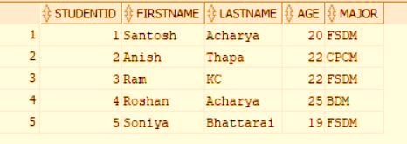

All data inserted is shown in the table by using select method

**2.2 Inserted table error**

* When constraints are not fulfill by the value being insert so it will display the error.
* Insert into Student_C0930325

Values (**1**,’Hari’,’Karki’,**14,**’FSDM’)

Where **StudentID** is **primary key** it should be unique and not null but 1 has been enter in primary key where 1 already exist. Along with that we have the **CHECK** constraint for the age which should be greater than 15 but the value is 14 which is less. So the inserted value display error message.

Error message

Insert will display error since Primary Key **1 for StudentID** already exist and **Age is 14 which is less than 15**

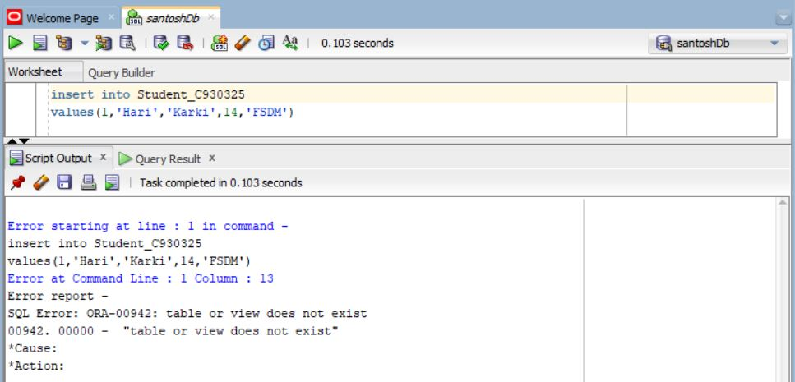

1. **Update data into table**

* Update is use to modify the data that has already been enter into the table.

1. **Updating the major data for the StudentID = 4**

* SQL query for update is
* Update Student_C0930325 set Major=’FSDM’ where StudentID = 4;

Update query where Major is update to **FSDM** for **StudentID 4**

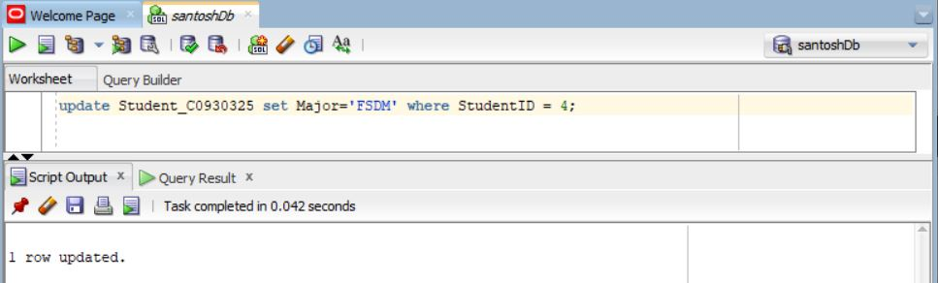

1. **Table after major is updated**

* While comparing the table from previous the major has been changed for Studen Id 4 from BDM to FSDM.

Before updating the table StudentID 4 has Major as **BDM** but after update it is **FSDM**

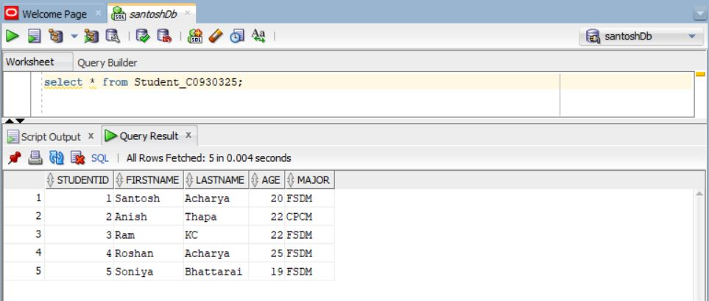

1. **Update age and major for the table**

Updating the age and major of the student 5. With use of the query

Update Student_C0930325 set Age = 20, Major =’CPCM’ where StudentID = 5;

Update query where Age and Major is update to **20** and **CPCM** for **StudentID 5**

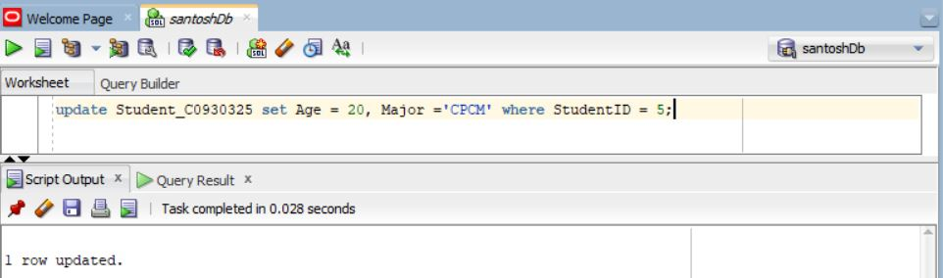

1. **Table after updating age and major**

* While comparing the table from the previous table view the data for the Student Id 5 has change from age 19 to 20 and Major from FSDM to CPCM.

Result to show the change

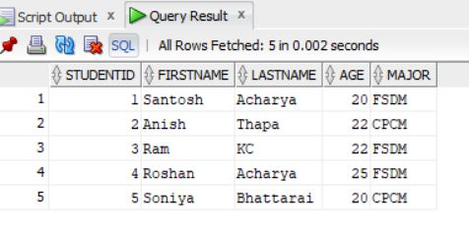

1. **Delete the data from table**

* Delete is use to remove the data from the given table from the database.

1. **Deleting data by Id**

* The data has been removed by the id from the table. Where student id 2 has been removed from table.
* **Delete from Student_C0930325 where StudentID = 2;**

Delete SQL query to remove the data using StudentID

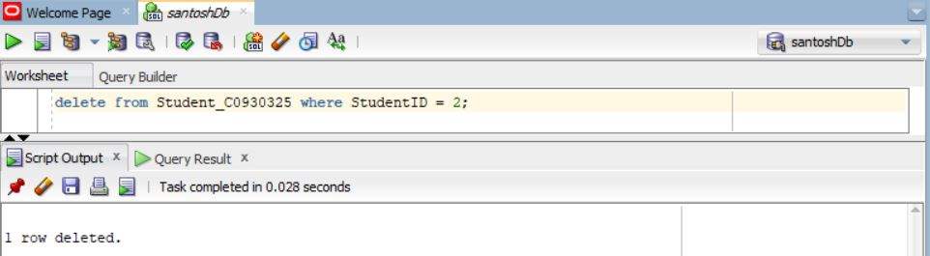

1. **Table after deleting by id**

* The below data show the table after the data has been deleted.

StudentId 2 has been removed from the table as there is no StudentId 2 between 1 and 3

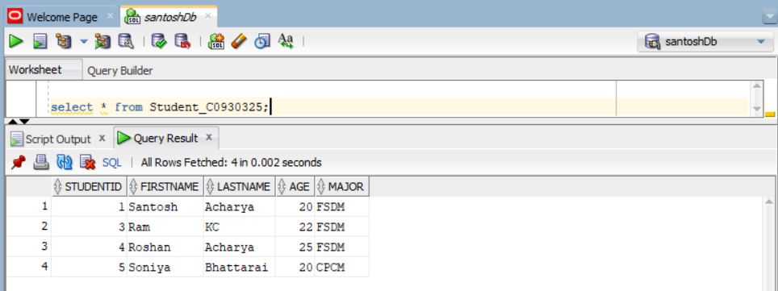

1. **Deleting the data by major**

* As data was delete by the Student ID it can also be delete by other column. Since student Id was primary key so only one data was deleted but by deleting by major could delete multiple column.
* SQL query for deleting data using major
* **Delete from Student_C0930325 where Major = ‘FSDM’;**

Delete SQL query to remove the data using Major

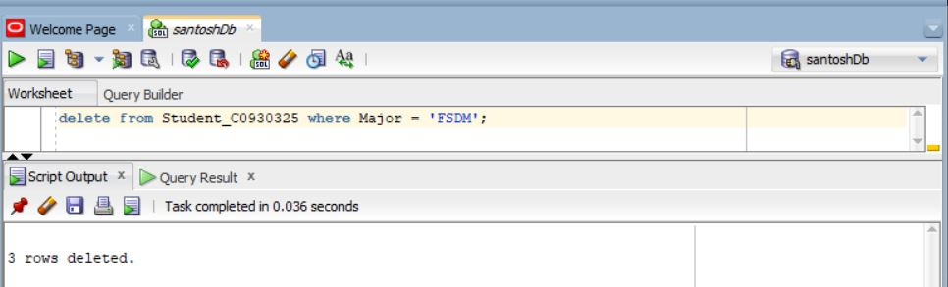

1. **Table after deleting by major**

* The table view after the data has been delete from the major.

All data with the Major as FSDM has been removed

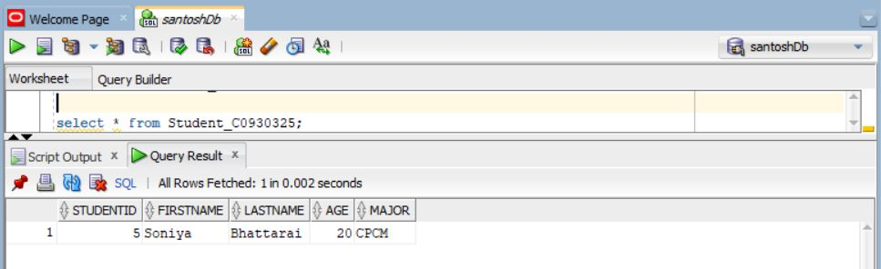

1. **Drop the table**

* Drop is use to remove the table from the database it will remove all the data and table also from the database.
* Truncate is also use to remove the table but it will remove all the rows from the table but will keep table structure intact.
* The table has been remove from the database after using the drop.
* SQL query to drop the table is

**drop table Student_C0930325;**

Result to show that table has been droped

SQL query to drop the table from SQL

